

Mini Project Report ON

**“**Object, Color and Distance Detection System**”**

Submitted in partial fulfillment of the requirements for the degree of Bachelor of Engineering in “**Information Technology Semester - VI**”

### By:

**Names ID No’s.**

Varun Singh VU4F1819016

Nishad Kadam VU4F1819021

Shashank Singh VU4F1819019

Under the Guidance of :- Prof. Ashwini Phalke



**Department of Information Technology**

**Vasantdada Patil Pratisthan’s College of Engineering and Visual Art**

Vasantdada Patil Educational Complex, Eastern Express Highway, Near Everard Nagar, Sion, Chunabhatti , Mumbai – 400022

**UNIVERSITY OF MUMBAI**

**April, 2021**



**CERTIFICATE**

This is to certify that the project entitled **“Project Analysis (Bug Tracking) System”** is a bonafide work of **“**Abhishek Karmokar (VU4F1819056), Sanchita Kolambe(VU4F1819050), Saloni Mundergi (VU4F1819020)**”**submitted to the University of Mumbai in partial fulfillment of the requirement for the award of the degree of **“Bachelor of Engineering”** in **“Information Technology Semester - VI”**.

Prof. Ashwini Phalke Guide

Dr. SEEMA LADHE Dr. ALAM N. SHAIKH

Head of Department Principal & Campus Director



Project Report Approval for T. E.

This project report entitled “**Object, Color and Distance Detection System**” by Varun Singh, Nishad Kadam, Shashank Singh is approved for the degree of **“Bachelor of Engineering”** in **“Information Technology Semester - VI”**.

### Examiners

1.

2.

Date:

Place: Mumbai-22

**ABSTRACT**

Bugs have been a part of a developer’s project since coding was invented. Bugs are logical defects in a program where some logic does not quite go well with some other logic implemented in the module. To overcome this, we proposed a tracking system which will upload, search and store bug data, time, type, seriousness, authenticity and if its solved or not. We are approaching by making a web app to store and search and upload project files for the need of bug searching. The Bug Data will be stored in the Database which will be accessed using SQLite Database Software. The WebApp is developed using Python Flask as it gives a Dynamic Type Website for smoother transitions. If a bug which has already occurred in any pre-developed software takes place in new system, it can be easily detected using the bug tracking system application. It serves as an assistant for a software engineer during debugging process. This Web Application uses HTML, CSS3 for Front-End and Python Flask for Backend Connections. This will help any software engineer to go through a project file while debugging process from anywhere in the world in a place with internet access.

Submitted by:



**Names ID No’s.**

Varun Singh VU4F1819016

Nishad Kadam VU4F1819021

Shashank Singh VU4F1819019



**TABLE OF CONTENTS**

**Abstract i**

1. **Introduction**
   1. Introduction 6
   2. Aim of the Project 6
2. Literature Survey
   1. Existing System 7
   2. Comparative study of literature survey 8

2.2 Proposed System 11

1. Requirement Analysis
   1. Software requirements 12
   2. Hardware requirements 12
2. System Design
   1. Data Flow Diagrams(DFD) 13
   2. UML Diagram 15
3. Implementation
   1. Source Code 16
   2. Screen shots 23

**References**

26

# Introduction

**INTRODUCTION**

* Ever thought how is the life of a blind person, their life is full of risk. They can't even walk alone through a busy street or through a park. They shall need some assistance from others.



* They are also curious about the beauty of the world, they should have will be the excitement to explore the world, and to be aware of what is happening in front of them
* So how we solve it, we have developed a pair of smart glasses for the blind. By using it, a person can able to know what is going on in front of him.

# Aim Of The Project

We have seen many people struggle with Bugs and they tend to forget to keep a record of it. It hence results to the redundancy or repetition of bugs and no one to remember how to fix it. There arises a need to get a system in place to record, remember and access any detail of a bug previously reported. No matter how much a code is polished there is always a logical issue conflicting with other lines of code written by other team members. Even bigger companies need a debugging software to debug the codes and remember the data of the bug. We focused on this problem as the world is shifting towards the digital era. Anyone with a laptop or computer can start coding and there should be a system to tell them to check for any loopholes possible in their code and possibly, if at all necessary share that module/part of code to other developers to make sure there isn’t many or any variations possible so that the code may crash or give unsatisfactory results.



**LITERATURE SURVEY**

# Existing System

* The current system uses  TensorFlow Object Detection API,it is  an open-source framework built on top of TensorFlow that makes it easy to construct, train and deploy object detection models
* There are already pre-trained models in their framework,which use different architecture and algorithms such as single shot detection, region based convolution neural network etc and thus provide different accuracies.
* The system then uses voice response (which conveys the name of the object) to the person using it



# Comparative Study of Literature Survey.

|  |  |  |  |
| --- | --- | --- | --- |
| Sr.No | Paper Title | Work Description | Conclusions |
| 1) | Object Detection and Human Identification using Raspberry Pi | The aim of this paper is to investigate the development of a navigation system for blind and visually impaired people along with human identification. It is based on a microprocessor with synthetic speech output. This solution is designed to give details about human whomever they encounter. | The proposed system has been developed and its main goal is to increase the capability of blind individuals. The technique used here is a well know name in imaging |
| 2) | Smart Glasses Application System for Visually Impaired People Based on Deep Learning | In this study, we propose a smart glasses application system for visually impaired people based on deep learning. The system can use voice response to visually impaired people about the objects in front of them by uploading the photos to our backend object detection system through the camera function of smart glasses, and then download the text descriptions of the result and then use the text-to-speech function. | According to the experimental results, the average time taken from the smart glasses to the voice output is 3.788 seconds, the overall recognition rate is 96.3% |
| 3) | Object Detection and Count of Objects in Image using Tensor Flow Object Detection API | This paper mostly focuses on detecting harmful objects like threatening objects. The model is built on two classes of threatening Objects. The model is evaluated on test data for the two classes of detecting threatening objects. | We built the model using Object Detection API. We trained model nearly 4500 steps to get a loss under 0.1 which took twelve hours and when we test the model with test images it performs well by giving better results. |
| 4) | Moving Object Detection: Review of Recent Research Trends | This paper provides a brief classification of the classical approaches for moving object detection. Further, paper reviews recent research trends to detect moving object for single stationary camera along with discussion of key points and limitations of each approach | During survey it was identified that shadow, illumination variation and dynamic background are the major problems which are worked over since these problems lead to reduction in the accuracy of successive steps of analysis process i.e., classification and tracking. |
| 5) | Moving Object Detection and Tracking from Moving Camera | In this paper, we deal multi moving object detection and tracking under moving camera. Moving objects are detected by homography-based motion detection. After moving objects are detected, we apply online-boosting trackers to track moving objects. | The key factors of our algorithem are: (1) homography-based motion detectiom, (2) onlne-boosting tracker, and (3) the integration of tracker and detection. |



* 1. **Proposed System**
* We aim to build smart glasses for physically challenged people that will allow them to get information about their surroundings independently
* The proposed system will detect the object which is In front of the person and will give information about it to the user with the help of speaker
* Various attributes of the objects such as the object name ,object color and object distance will be informed to the user by this system



**REQUIREMENTS ANALYSIS**

# Software Requirements:

* + - OS: Windows 8 or Above
    - For Project:

1. Python 3.8
2. Visual Studio Code or Jupyter Notebook For Code Execution
3. Tensorflow
4. Open CV
5. Rasberry Pi 4
6. Camera Module
7. Speaker Module
8. Pandas and Numpy (Optional) for Data Analysis and Numerical Operations
   * + For User:
9. Eyewear



**IMPLEMENTATION**



* 1. **Code:**

Code for Object Detection of a Static Image

Image Provided:-



Code:-

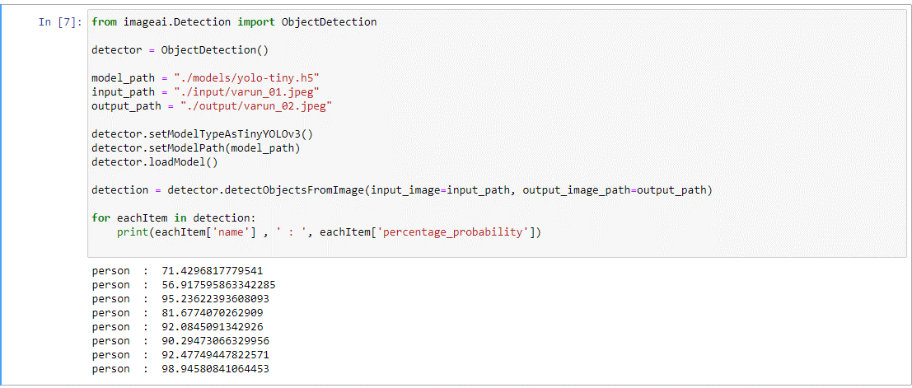

Image Recived as Output:-

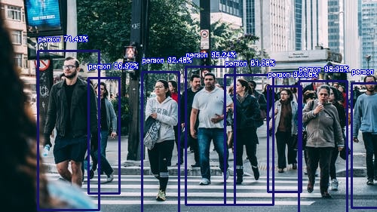



**CONCLUSION**

### We all know that the world is working towards making everything automated and many projects are under process and there needs to be system to make sure that all the problems and issues faced by the software developer has to be sorted and stored somewhere. Like all data, bug’s raw data can also be turned into information to manage the project to see who is conflicting more with logic produced by the team and make sure he/she corrects it. We all have faced going through Logical problems and loopholes while executing a program. This system just makes sure all the mistakes done by a human be recorded for future reference and in all give a report of the bug addressed and solved in a project completed. Any similar bug related to a similar project can be viewed and how it was solved can also be viewed to get a faster approach towards the bug and get it cleared as soon as possible.